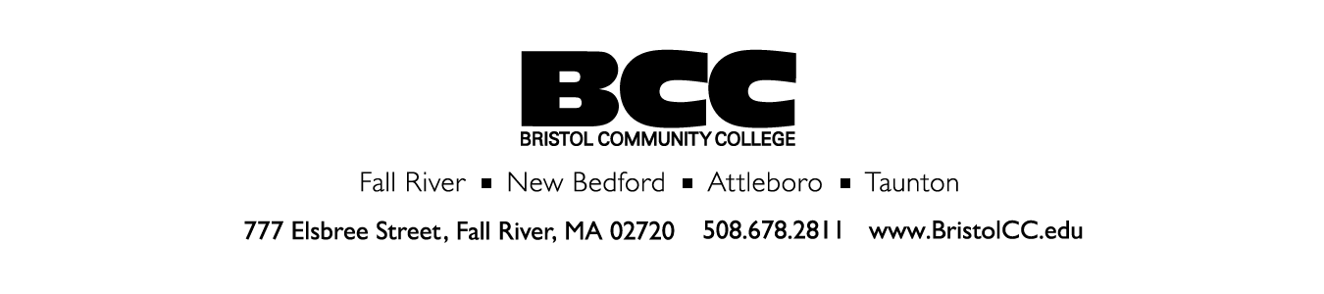
Board of Trustees Self-Assessment
Enclosed you will find 20 items requiring a rating. Next you will be asked to answer 2 open-ended questions. Please complete the entire survey and return it for confidential compilation as directed in the cover letter. Thank you for your participation.
Please rate our Board of Trustees on a scale of 1 (less favorable/strongly DISAGREE with statement) to 5 (excellent/strongly AGREE with statement).
 | DISAGREE  1 | 2 | 3 | 4 | AGREE  5
Educational Mission
1. The Board monitors the effectiveness of the College by using the Mission and Values as a guide.
2. Trustees keep abreast of issues in higher education through reading and research, and/or by attending local activities or regional/national meetings or conferences as recommended by the Chairperson.
Governance and Performance Accountability
3. The Board participates in annual self-appraisal.
4. The Board as a whole and the individual board members participate in:
a. The annual evaluation of the President of the College.

b. Community activities as advocates for and supporters of the College.

c. Support for the President and administration by promoting clarity between the policy-making role of Trustees and the roles of President and staff.
 | DISAGREE  1 | 2 | 3 | 4 | AGREE  5
Financial Oversight
5. The Board ensures the budget reflects priorities of the College as defined by its mission and goals by addressing:
a. Programmatic needs and staffing levels.

b. Parameters for investments and management of assets.

c. Facility maintenance and appearance.
6. The Board ensures all budget parameters are consistent with accepted audit standards.
Philanthropy
7. Trustees understand the needs of the College. They support and collaborate with the Foundation
8. Trustees support fund-raising efforts through personal contributions, attendance at events, and/or direct involvement in development and execution of fund-raising events.
Participation
9. Board meetings are conducted in an orderly and efficient manner and allow sufficient time/opportunity for discussion.
10. Trustees support the mission and goals of the College by:

a. Achieving attendance requirements for plenary meetings such that a quorum is consistently reached.

b. Attending and actively participating in meetings for appointed subcommittees.
Planning
11. The Board participates in community activities and presentations that promote learning regarding key community/organizational initiatives or potential collaborations that might advance the mission of the College.
 | DISAGREE  1 | 2 | 3 | 4 | AGREE  5
12. The Board annually measures the organization’s performance against goals defined in its Strategic Plan.
Identification of New Trustees
13. The Board’s selection and nomination process:
a. An open process while names of nominees are not made public.

b. Attracts excellent candidates.

14. Trustees:
a. Provide objective input regarding the specific talents of individuals needed to fill prospective vacancies to support the College’s future, and

b. Have the opportunity to forward suggestions of individuals to the Nominating Committee for consideration.
Public Support and Visibility
15. Trustees act as representatives of the College when attending events sponsored by or for BCC, recognizing that policy is the “voice” of the Board; the Board operates as a unit, only the Chair has the authority to speak for the Board or the College.

16. The Board as a whole is sufficiently visible at College events including commencement, awards presentations, special student/staff events as suggested by the Chair.
Stewardship
17. Decisions made by the Board are supported publicly by all members.
18. Board decisions about resource allocations support the College’s mission and goals.

 | DISAGREE  1 | 2 | 3 | 4 | AGREE  5
General Conduct and Conflict of Interest
19. The Board ensures all members identify and disclose any actual or potential conflict of interest and acts at all times for the public good, putting the welfare of the College and its future before personal interests or relationships.
20. All plenary and sub-committee meetings of the Board:
a. Address BCC business only.

b. Comply with the Open Meeting Law.

c. Promote open discussion and respect for all points of view.

Please see the next page for open-ended questions.

Trustee Self-Assessment

Open-ended questions:
Excellent Leadership results in excellent performance.
1. What were the major accomplishments of the Board in the past year?

2. If not addressed in the questions on the previous pages, what, in your opinion, are areas in which the Board could improve?

3. What particular project do you think will improve and benefit the student body, and one that
you would like to lead? (Please see attached examples.)

Thank you for your participation.

Date of issue:_______________________

Date of completion: _________________

EXAMPLES OF PARTICULAR PROJECTS

Cynthia Rose:
One of the issues that I am interested in at the campus would be the new programs and how we get the word out to the community that these are being offered. When a student comes to register, they might not know that these courses are being offered. I think it would be beneficial to either advertise new programs once we approve them or maybe do a mailing with some other information to talk about new programs whether they are degrees or certificates. Thank you.

Max Volterra:
I am interested in the connection between the large number of students entering BCC that do not have the necessary skills to take on BCC without remedial education – and the current educational standards for graduation from secondary schools.

The goal is to reduce the number of BCC students required to enter remedial courses, and those who do not progress to regular BCC courses.

Diane Silvia:
I always felt that it is important for BCC to engage with high school juniors and seniors, voc tech as well, to make them aware that BCC is quality at a reasonable rate, especially if the student is not so sure of their passion. It is not feasible to send tens of thousands on courses when affordable transferable education is in their community. Also, the clinical or lab experiences at BCC seem to prepare students to better adapt to the workplace setting then the four year. I know the school does this to some degree, but engaging alumni who have graduated from different degree programs give testimony of BCC’s influence on their careers and lives can be inspiring and credible.

Cynthia Rose:
I have a couple of suggestions for the retreat especially after going to the meeting at MassBay on Thurs. As you know, I did ask the Commissioner about coming to one of our meetings so everyone can meet him with the idea of asking him any questions as pertaining to our school – he stated that he would like to very much come to a meeting. I did suggest that he come to our retreat which is held in August and he said that would be a good idea. He did ask me when it would be and I did not know if we had a date yet but his schedule (as he told me) is he would not be available from Aug 1 – 16th. I think it would be beneficial to us if we had the retreat after so (hopefully) he would be able to make it. I told him that we usually meet at 8:30 and it goes until at least 1:00 p.m. and his response was he would pick a slotted time to be there. I don’t know if a meeting was held and a date picked but could we e-mail him an invitation soon as you pick a date with your committee?

The other suggestion for the retreat was to talk about the situation for safety but I am sure that will be on the agenda. I believe arming or not arming would probably be a topic we would talk about sooner than later but if not, then this should be in the forefront. Thank you.

