The Massachusetts Office of Student Financial Assistance
Action Letter #2

March 2020
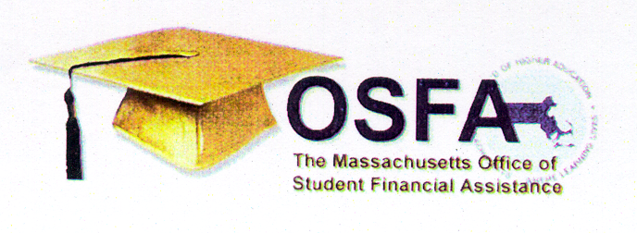
2019-2020 Post-Withdrawal Eligibility for State Aid

ACTION
LETTER
1999-2000 PROGRAMS GUIDELINES UPDATES

Assistance

Dear Colleague:

This Action Letter provides guidance to institutions vis-à-vis students’ eligibility for state financial aid programs, after they have withdrawn from the institution due to circumstances related to COVID-19, during the award year 2019-2020.

During the academic year 2019-2020, a student may be eligible to receive assistance from Massachusetts state financial aid programs after having withdrawn from an institution due to circumstances related to COVID-19. The following conditions must be met for the post-withdrawal eligibility to be effective:

Student must have met the financial aid program’s requirements prior to their withdrawal from the institution.

Funding under the financial program must be available during the post-withdrawal period.

Disbursement must occur no later than June 30 of the 2019-2020 award year

Institutions are invited to contact the Massachusetts Office of Student Financial Assistance at 617.391.6070, if they have any questions or need further clarification about the above policy.

Thank you,

Massachusetts Office of Student Financial Assistance

