Developed with support from:  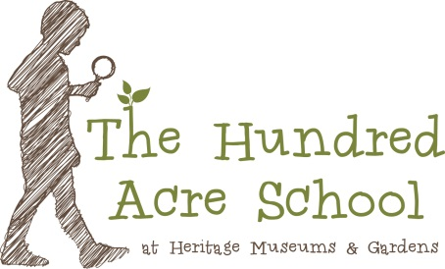 | Collections: A STEM Focused Curriculum  Developed by Kori Bardige & Melissa Russell  Implementation Guide available www.100acreschool.org  Vision  The Collections Curriculum encourages children to be curious, to wonder, think, play, question, and connect with the world around them, so they will become innovators able to make great contributions to society.  About the Curriculum  This curriculum is designed for preschoolers, specifically 4-5 year olds. It covers all domains of development, but focuses teaching and learning activities through a STEM lens. The learning environment (indoors and out) had been carefully designed to promote STEM explorations and support and enhance the curriculum.  The curriculum is divided into Investigations for in-depth study of each topic. Following an emergent curriculum philosophy, the Investigations serve as a guide for teachers as they capitalize on children’s and families’ interests in each topic and design lessons based on children’s inquiry questions. Each Investigation has been selected to cover all objectives outlined by the Massachusetts Preschool Learning Experiences developed by the Massachusetts Department of Early Education and Care and is aligned to a standardized assessment tool.  This curriculum begins with investigating STEM tools to introduce children to the Scientific Method. The goal is to encourage children and families to explore inquiry learning and how to use tools to test their theories. The tools introduced in this initial Investigation will then become part of the instruments used for other Investigations. Using the Scientific Method becomes a way for children to organize their ideas, develop and test hypotheses, and build upon their knowledge.  Every Investigation begins with provocations designed to get children and families talking and asking questions about STEM concepts related to the specific Investigation. As children’s questions emerge, teachers will design activities to help children test their hypotheses and further their learning. Teachers expand the investigation based on children’s interests and experiments using lab reports that document their hypotheses. Investigations culminate in the creation of an Exhibition where children share what they have learned with others.

