Massachusetts

Inclusive Concurrent Enrollment Initiative
A Report to the Legislature: 2014-2016

Prepared by the Executive Office of Education
James Peyser, Secretary
© 2016 Executive Office of Education

Massachusetts Inclusive Concurrent Enrollment Initiative
A Report to the Legislature: 2014-2016

Prepared by the Executive Office of Education
James Peyser
Secretary

© 2016 Executive Office of Education
Permission is hereby granted to copy any or all parts of this document for non-commercial educational purposes. Please credit the “Executive Office of Education.”

This document printed on recycled paper

Executive Office of Education
Commonwealth of Massachusetts
One Ashburton Place, Suite 1401
Boston MA 02108
Phone: (617) 979-8340
Fax: (617) 727-0049
Email: EOE@massmail.state.ma.us
http://www.mass.gov/edu/

Contents

Letter from the Secretary 1
Purpose of the Report 2
History of the Inclusive Concurrent Enrollment Initiative 3
Utilization 5
Participating Institutions 6
Participating School Districts 7
Students Served 7
Racial & Ethnic Characteristics 8
Classes & Pedagogy 8
Credit & Audit 8
Student Employment Outcomes 9
Systems-Change Outcomes 9
Public Awareness Results 9
Program Administration Results 10
Technical Assistance and Professional Development Results 10
Research and Evaluation Results 11
Program Staffing 11
Appendices
Appendix A: FY2016 Budget Language 13
Appendix B: Brief Literature Review 14
Appendix C: Student Spotlight (George Lindesey-Travis) 15
Appendix D: Student Spotlight (Leslie Garcia) 16

Letter from the Secretary

May 2016

Members of the General Court:

I am pleased to submit for your review, “Massachusetts Inclusive Concurrent Enrollment Initiative: A Report to the Legislature: 2014-2016.”

Since the Executive Office of Education assumed responsibility for the Massachusetts Inclusive Concurrent Enrollment Initiative (MAICEI) in January 2014, it has continued to expand this network of grant-funded partnerships between schools and public colleges and universities offering inclusive concurrent enrollment programs for students with severe disabilities between the ages of 18 and 22.

As the initiative moves towards its ten-year anniversary, the number of participating partnerships has expanded to 16, serving over 250 students per year. The EOE is pleased to support students with intellectual disabilities as they participate in both credit and non-credit courses alongside their non-disabled peers; develop self-determination and self-advocacy skills; improve academic, social, and functional skills; and participate in career planning, vocational skill-building activities, and community-based integrated competitive employment opportunities.

If you have any questions about the program or this report, please feel free to contact Glenn Gabbard, State Coordinator of the Massachusetts Inclusive Concurrent Enrollment Initiative at 617.979.8335 or via email at Glenn.Gabbard@state.ma.us.

Sincerely,

James Peyser
Secretary, Executive Office of Education

Purpose of the Report
This report follows a series of reports issued in April 2009; March 2012; and March 2013.

The Executive Office of Education is pleased to submit “Massachusetts Inclusive Concurrent Enrollment Initiative: A Report to the Legislature: 2014-2016” pursuant to Chapter 46 of the Acts of 2015, line item 7009-9600 (see full text in Appendix A):

For a discretionary grant program to provide funds to school districts and public institutions of higher education partnering together to offer inclusive concurrent enrollment programs for students with disabilities, as defined in section 1 of chapter 71B of the General Laws, between the ages of 18 and 22, inclusive; provided, that the grant program shall be limited to students who are considered to have severe disabilities and, in the case of students age 18 or 19, shall be limited to students with severe disabilities who have been unable to achieve the competency determination necessary to pass the Massachusetts Comprehensive Assessment System exam...

The purpose of this grant program is to build partnerships between high schools in public school districts and state public institutions of higher education (IHE) to develop inclusive concurrent enrollment programs for students with severe disabilities between the ages of 18 and 22. FY16 marks the 10th year of this program. Data used for this report is compiled from the Massachusetts Inclusive Concurrent Enrollment Initiative (MAICEI) program and reports submitted by MAICEI partnerships.
Though legislative funding for the MAICEI has been consistent since 2007, 75% of the current partnerships have been in place for five years or less. After authority for the program was shifted to the Executive Office of Education in January 2014, program expansion, outreach and public awareness, and quality assurance of existing programs continued as important priorities. This report is intended to provide information about the growth of the initiative; its impact on participating students; and emerging opportunities and challenges which inform policy development and implementation for inclusive post-secondary opportunities within the Commonwealth.
As a small, state-based grant program that has only recently enjoyed dedicated full time administrative leadership of the program, MAICEI is still evolving and learning from program participants who have benefitted from the program over the years. The first cohorts of higher education institutions have only recently begun to explore and implement sustainability models that hold promise for bringing the program to scale and developing the kinds of cross-agency collaborations that will help young people make successful transitions from the public schools to the adult world of community-based employment and lifelong learning opportunities.

History of the Massachusetts Inclusive Concurrent Enrollment Initiative
Nationally, the growth of programs serving students with intellectual disabilities in colleges and universities has increased steadily; currently there are over 250 such programs across the country. Relatively few of these programs serve students who are 18-22 in a dual or concurrent enrollment environment; even fewer support students in fully inclusive learning environments. Recognizing that many students are unable to earn their high school diplomas due to the severity of their intellectual disabilities, the Massachusetts State Legislature passed budget language in 2007 supporting the development of a network of grant-funded partnerships between public colleges and universities and school districts to plan, implement, and sustain authentically inclusive academic, social, and career development experiences on college campuses. At age 18, many of these students had remaining academic, social, and career development transition goals that were to be addressed through students’ individualized education programs (IEPs). The intent of the Massachusetts Inclusive Concurrent Enrollment Initiative was to address these outstanding goals by providing access and supports to success in academic, social, and career development experiences for eligible students with intellectual disabilities alongside their non-disabled peers enrolled in the Commonwealth’s public two- and four-year colleges and universities.
Because of the growth of the 18-22 age student population with cognitive disabilities with significant needs and the requirement to support their transitions to adult services, many school districts have been challenged by the need to develop inclusive transitional experiences at school sites. An additional challenge was developing such experiences to assure inclusion alongside similarly aged non-disabled peers. The majority of both disabled and non-disabled peers for this population of students had already graduated or completed their high school experiences and moved onto the college, work, and other experiences in the adult world.
Currently, 16 MAICEI programs are providing fully inclusive services and supports to over 200 18 to 22-year-old Massachusetts students with intellectual disabilities which prevent them from completing the statewide competency exam (MCAS). Since 2007, over 1,200 students have had the opportunity to take part academically and socially in the life of the college, and also to:

- discern their own preferences, interests, needs, and strengths through Person-Centered Planning;
- become advocates for their own choices and decisions around academic, social, and work activities;
- acquire career and life skills by taking inclusive college credit and non-credit bearing courses that relate to their career goals and other areas of interest;
- access student support services, as other college students would;
- participate in the life of the college; and
- experience integrated competitive employment opportunities.

In 2014, responsibility for administering the initiative was transferred from the Department of Elementary and Secondary Education to the Executive Office of Education. Based on legislative budget language (see Appendix A), the administrative responsibilities for the Executive Office of Education extend to five major areas:

- providing technical assistance to existing programs—particularly to college personnel—in order to promote access and success for students;
- supporting expansion of the network of participating partnerships of colleges, universities, and school districts while at the same time promoting uniform standards of program quality consistent with the intent of the legislatively approved budget language;
- providing technical support to programs to create self-sustaining programs, based on resource development available through existing school and college funding as well as encouraging collaboration with other state agencies, including the Massachusetts Rehabilitation Council and Department of Developmental Services;
- supporting rigorous evaluation of existing programs and ongoing research focused on program quality and sustainability; and,
- developing ongoing public awareness strategies to inform prospective students, their families, school districts, and other related service providers about opportunities for program development where none exist and how to participate in existing programs.

Through its MAICEI State Coordinator, EOE:
- administers the development and awarding of three types of grants supporting program development, quality assurance and accountability, and sustainability:
  - one-year planning grants for both residence life and non-residence life opportunities of up to $20,000 per grant;
  - five-year non-residence life implementation grants of up to $105,000 per grant; and
  - grants designed to support the design and implementation of residence life experiences for program participants;
- coordinates the state advisory committee;
- develops new partnerships;
- assists existing partnerships to create self-sustaining models;
- oversees the development of videos and informational materials;
- designs system-wide evaluation strategies; and,
- designs professional development activities based on practitioner-based research as well as studies conducted through UMass Boston’s Institute for Community Inclusion, an established national leader of the “Think College” movement, a consortium of two and four-year colleges offering post-secondary learning opportunities for students with intellectual disabilities.

Utilization
During the 2014-2015 academic year, roughly 3,000 Massachusetts public school students were potential candidates for participation in the Massachusetts Inclusive Concurrent Enrollment Initiative. MAICEI programs active during that time period served approximately 5% of that total.

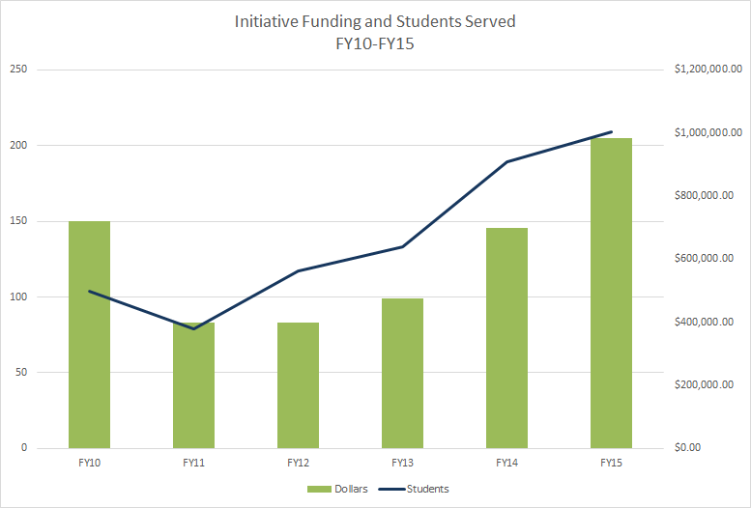

Preliminary data suggests that the level of legislative funding and the number of students served by the MAICEI program are related. Both funding levels and student enrollment have been steadily climbing since FY12. Continuing this trend, FY16 student enrollments indicate a steady increase in students served (indicated by an unduplicated headcount n=269). Continuing to examine the relationship between funding and student enrollment is a priority throughout FY16.

Participating Institutions
MAICEI maintains an active presence on more than half of the 26 total public institutions of higher education in Massachusetts (including the community colleges, state universities, and University of Massachusetts campuses). During FY16, the number of participating campus partnerships expanded to 16 with the award of planning grants to Salem State University and Mt. Wachusett Community College. In addition, Bridgewater State University was awarded a first-phase implementation grant to organize and create the administrative and training infrastructure to support residence life opportunities on that campus starting Fall 2016.

Growth in campus participation has been steady over the history of the initiative. The majority of participating campuses are community colleges, but there is growing interest by state universities (in particular, Framingham State University and Salem State University). UMass Boston and UMass Amherst are both active MAICEI grantees and are the only two active campuses from the UMass system.
Sustainability. Most partnerships are funded through Initiative grants; two have completed the grant-supported planning and implementation cycle, are no longer receiving Initiative funding, and continue to partner with school districts to offer inclusive concurrent programming on their campuses. Grant-funded participants receive their operating funds directly through MAICEI; all campuses participate in a planning year before they begin accepting students into their programs. Both Holyoke Community College and MassBay Community College have continued program offerings after the end of grant funding from the Initiative. Westfield State University and Bridgewater State University are actively working to finalize their transitions to self-sustaining models.
As part of the grant application procedure, campuses applying for grant funding are required to include proposals for studying, developing, and implementing plans for transitioning to self-sustaining status. The goal of sustainability of MAICEI programs has been and continues to be a driving force behind campus program innovations.

Participating School Districts
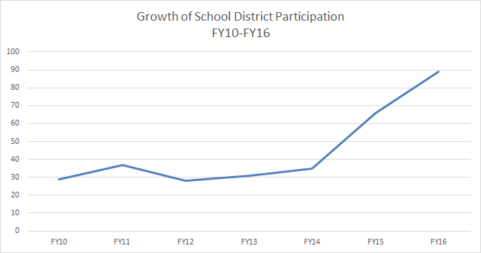
The number of partners a college campus program may have is generally decided in the initial grant-making phase. Campuses are required to identify at least two school districts that have both a need for MAICEI services and students who could take advantage of the program. As MAICEI programs are heavily dependent on collaboration between campus and school district partners, strong leadership at both institutions is needed to ensure smooth operation.
School district partici-pation has increased signif-icantly as the successes of MAICEI become more widely recognized; the program has seen growth from 29 active districts participating in FY10 to 59 in FY16. This trend indicates that school districts (and families in those districts) will continue to reach out to their local college campuses in an effort to capitalize on MAICEI’s successes.

Students Served
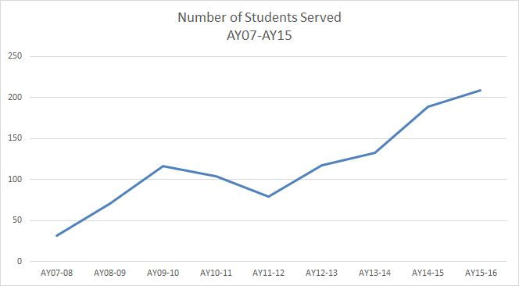
The student population served by MAICEI programs throughout the Commonwealth has also been steadily increasing throughout the history of the Initiative. From Fall 2007 to Spring 2016, the number of students actively participating in MAICEI programs more than quadrupled from 31 students to over 200. As noted in the Utilization section above, the ability of MAICEI campuses to serve students has steadily increased parallel to funding levels. Additionally, as MAICEI has historically served only approximately 5% of the eligible student population, every indication suggests that demand for MAICEI services will increase in the coming years.

Racial & Ethnic Characteristics

The student population of the Massachusetts Inclusive Concurrent Enrollment Initiative is generally comparable in diversity to the population of students enrolled in the public schools of the Commonwealth. Black or African-American students made up a significantly larger proportion of MAICEI participants in AY2014-15. As program participation grows and the program matures, it will be important to monitor and evaluate the relationship between the MAICEI population and the broader population from which it is drawn.

Classes & Pedagogy
Student participants in MAICEI take a wide variety of classes in different fields and disciplines. In FY15 alone, MAICEI students took 184 discrete classes ranging in topics from Computer Essentials to Zoology. Most popular are liberal arts and humanities classes, which accounted for more than 20% of all classes taken.
Although all types of pedagogical styles are represented in class selection, students most frequently select small group (e.g. Introduction to Business, Critical Thinking, and Human Growth & Development) and applied learning (e.g. Wellness Programming, Design Fundamentals, and Human Biology) pedagogical types.

Credit & Audit
MAICEI students have the option of taking any class for credit or on an audit basis, just like their non-disabled peers. Variability across campuses is common; some campuses have more students taking classes for credit than others. However, because all MAICEI students are eligible for student services offered to all students at participating colleges and universities, many MAICEI program students use in-class learning resources (peer tutoring, writing/math center supports, etc.) regardless of whether they are taking a class for credit or on an audit basis.
Although the majority of students audit classes, MAICEI participants complete courses at phenomenal rates; in AY13-14, 97% of those classes begun by MAICEI students were completed satisfactorily.

Student Employment Outcomes
Securing and retaining long-term employment is a stated goal of many MAICEI students and career development is a key objective of the program. This goal shapes much of the person-centered planning process, including course selection, credit/audit choices, and supplemental soft-skills training. Educational coaches, typically hired by the school district partners in each program, are vital to the process of aligning program and campus resources with student needs. Equally important are the career development resources which the college and university provides.
Some MAICEI students have limited employment options based on their geographic locations. Variability in job opportunities between different geographic regions of the state is to be expected; however, preliminary data suggest that significant disparities in employment success of program participants between physically proximate campuses may exist, lending credence to a hypothesis that it is program characteristics, rather than job availability, that determines whether or not MAICEI students find employment during and after enrollment in their respective programs. Capturing post-program employment data is a goal of the new evaluation system; student follow-up and an analysis of emerging post-enrollment employment data will be crucial to evaluating program impact.

Systems-Change Outcomes
Because of its role in facilitating communication and coordination between the Department of Elementary and Secondary Education and the Department of Higher Education, the Executive Office of Education’s role in supporting the Massachusetts Inclusive Concurrent Enrollment Initiative has centered on:

- Public Awareness through community outreach, public presentations, and media development;
- Program Administration through grant administration and budget oversight for the state appropriated funds;
- Technical Assistance and Professional Development for funded partnerships; and,
- Research and Evaluation supporting work to identify student and program level outcomes which reflect national standards for inclusive post-secondary programs for students with intellectual disabilities.

Public Awareness Results
- Public presentations at approximately 50 different international, national, state, regional, and community meetings, conferences, and televised interviews;
- Creation of an Initiative website to promote public awareness among schools, colleges and universities, state-level offices offering related adult services; community organizations, and individual citizens;
- Re-design and publication of promotional materials, including a project brochure and map available for distribution at public presentations and for download access from the Initiative website;
- One-on-one in-person, electronic, and telephone consultation and technical assistance with interested school district personnel; college/university personnel; family members; and adult service organizations;
- Regular information updates to statewide database of policy-makers, providers, legislators, school and higher education personnel, family members, service providers, and community members;
- Formation and meeting facilitation of statewide advisors group, comprising representatives from participating schools, colleges, funded programs, self-sustaining programs; advocacy groups; technical assistance experts in post-secondary inclusive programs; state legislators; family members; former students; and, representatives of state agencies, including Department of Elementary and Secondary Education; Department of Higher Education; and, the Department of Developmental Services. The advisors group meets six times per fiscal year.

Program Administration Results
- Issuance of Requests for Proposals (RFPs) that more closely align with national quality indicators for inclusive post-secondary programs;
- Issuance of Request for Proposal (RFP) for a residence-life program which will include students eligible for MAICEI in dormitory life as well as related supports to facilitate the development of essential adult living skills best acquired in community environments that include both non-disabled and disabled peers. Once implemented, Massachusetts will be the first state to offer residence life opportunities to students receiving transitional special education services through their local school districts while attending public colleges and universities.
- Availability of technical assistance documents related to submission of proposals in response to RFPs posted on the Initiative website;
- Standardized, revised grant review rubrics, more closely aligned with quality indicators for inclusive post-secondary programs; and,
- Development of EOE-based grants management system that offers quicker turnaround of funding-level status throughout the grant year, thereby ensuring more efficient and complete use of grant funds to benefit students.

Technical Assistance and Professional Development Results
- In collaboration with the Institute for Community Inclusion at UMass Boston, generated two webinar series, one for FY15 and the other for FY16, focusing on twelve different issues critical to supporting effective community-based transitions for young adults with intellectual disabilities. Web-based recordings of all presentations are distributed to the individuals on the Initiative database and are made available on the Initiative website;
- In collaboration with Westfield State University, implementation of a statewide conference focusing on “Emerging Trends in Inclusive Post-Secondary Programs for Students with Intellectual Disabilities.” The conference brings together approximately 130 program staff from both university/college and school sectors, including representatives from prospective school and college/university partners; higher education and school administrators; researchers, family members, including those of prospective program participants. This is a unique statewide opportunity to focus conversations about high quality transition services and supports on inclusive, community-based opportunities. The conference is free to individuals affiliated with a funded or self-sustaining program; a nominal fee is charged to other participants;
- Development of a program assessment protocol to establish quality benchmarks for grant-funded programs. The “Think College” indicators, used to guide initial grant proposal development, are again used to discuss ongoing program development, once funding is granted;
- Development of a regularly scheduled site visit protocol and schedule to assure ongoing connection between the EOE and grantees;
- In collaboration with the Department of Elementary and Secondary Education, created a moderated online professional development forum for coordinators of all MAICEI programs; and,
- Organization of monthly coordinators’ meetings and a mid-year in-person conference to assure stronger group coherence, communication, and quality assurance across grantees.

Research and Evaluation Results
The Massachusetts Inclusive Concurrent Enrollment Initiative has similar evaluation challenges to other medium- and long-term educational & social service programs. Past system-level evaluation efforts—primarily via post-program student success—have been challenging because of the lack of standardized data collection procedures, lack of awareness of the importance of evaluation & student follow-up, and inconsistent campus participation.
Continuing its evolution as a relatively small, state-based grant program, MAICEI has begun to take steps to remedy this situation. In April of 2015, MAICEI began to use the Data Collection and Evaluation System developed by the Think College national coordinating center housed at the Institute for Community Inclusion at UMass Boston. New campuses will input a wide range of student and program data going forward, and participating campuses will enter past data in order to ensure access to and analysis of historical program and student trends.
Preliminary information being collected on the campus level includes in-kind funding, staff-to-student ratios, student employment outcomes, and detailed class discipline breakdowns.
Preliminary student-level data includes demographic & housing information, job placement particulars, and medium-term (1-5 years) successes.
It is hoped that an Initiative-wide cultural shift surrounding the usefulness of the new evaluation system will translate into better data collection & management, an interest in measuring the long-term successes of campus programs and students alike, and a sense of how both contribute to continuity of service.
MAICEI expects that these initial efforts to collect and analyze student- and program-level data will inform the future course and appropriate improvements to this promising and exciting initiative.

Program Staffing
All Massachusetts Inclusive Concurrent Enrollment Initiative grant-funded programs follow roughly the same staffing guidelines (a program coordinator, half-time employment specialist, and supplemental support, if needed, for education coaches (the primary costs of which are paid for by school districts)).
Educational coaches are crucial to the success of the program and its students. (School district partners typically pay salary and benefits for educational coaches.) They have the most day-to-day contact with MAICEI students and, as such, carry a wide range of responsibilities, including implementing IEP goals and recommendations, and aligning student goals with available campus resources.
Several campuses have instituted innovative peer mentoring and coaching strategies in addition to and in concert with educational coaches. These strategies are designed to augment their already successful programs. Of particular note is the peer mentor program at Westfield State University, which links interested and motivated students to MAICEI students both individually and in groups.
Campus administrators, parents, and students have praised these evolving strategies. MAICEI continues to explore new ways to bring these strategies—and their creative motivations—to other campuses and believes they represent promising opportunities to expand program utility within program financial constraints.
Generally, each campus has a full-time coordinator dedicated to running the MAICEI implementation (in FY16, 8 of 12 campuses had full-time coordinators). In rare cases, the coordinator has additional responsibilities on campus. The average salary for MAICEI program coordinators from FY16 is $36,605 (when fringe is included, this expense represents an average of approximately 58% of the total program budget). Most campuses also employ additional program staff noted above (as of FY16), accounting for an additional average of 15% of program funding. An equivalent 15% is spent on student & course fees. The remaining 14% of program funding is typically split between supplemental costs for educational coaches, supplies and materials, student transportation, and indirect expenses. The table below breaks down where those funds are distributed (percentage values will not sum to 100% as these values are averaged across participating campuses).

 | Average Percent of  Total Grant | Average Approximate  Funding Level
Coordinator | 46.29% | $37,871.54
Other Campus Staff | 14.98% | $12,258.41
Student/Course Fees | 14.45% | $11,823.37
Coaches | 14.19% | $11,607.06
Fringe | 11.75% | $9,610.27
Consultants | 9.54% | $7,804.77
Indirect | 8.00% | $6,544.85
Student Transportation | 6.45% | $5,274.83
Supplies/Materials | 4.12% | $3,374.71
Training & Professional Development | 3.17% | $2,592.37
Travel | 2.57% | $2,103.33

Appendix A: FY2016 Budget Language

Chapter 46 of the Acts of 2015, line item 7009-960

For a discretionary grant program to provide funds to school districts and public institutions of higher education partnering together to offer inclusive concurrent enrollment programs for students with disabilities, as defined in section 1 of chapter 71B of the General Laws, between the ages of 18 and 22, inclusive; provided, that the grant program shall be limited to students who are considered to have severe disabilities and, in the case of students age 18 or 19, shall be limited to students with severe disabilities who have been unable to achieve the competency determination necessary to pass the Massachusetts Comprehensive Assessment System exam; provided further, that said students with disabilities shall be offered enrollment in credit and noncredit courses that include non-disabled students, including enrollment in noncredit and credit bearing courses in audit status for students who may not meet course prerequisites and requirements, and that the partnering school districts shall provide supports, services and accommodations necessary to facilitate a student's enrollment; provided further, that the executive office of education shall develop guidelines to ensure that the grant program promotes civic engagement and mentoring of faculty in public institutions of higher education and supports college success, work success, participation in student life of the college community and provision of a free appropriate public education in the least restrictive environment; provided further, that the executive office of education shall develop strategies and procedures to help sustain and replicate the existing inclusive concurrent enrollment programs initiated through this grant program including, but not limited to: (i) provision of funds to retain employment specialists; (ii) assist students in meeting integrated competitive employment and other transition-related goals; (iii) adoption of procedures and funding mechanisms to ensure that new partnerships of public institutions of higher education and school districts providing inclusive concurrent enrollment programs fully utilize the models and expertise developed in existing partnerships; and (iv) conducting evaluation and research to further identify student outcomes and best practices; provided further, that the executive office of education shall develop a mechanism to encourage existing and new partnerships to expand the capacity to respond to individual parents that request an opportunity for their children to participate in the inclusive concurrent enrollment initiative; provided further, that tuition for courses shall be waived by the state institutions of higher education for students enrolled through this grant program; provided further, that the executive office of education shall maintain the position of inclusive concurrent enrollment coordinator who will be responsible for administering the grant program, coordinating the advisory committee, developing new partnerships, assisting existing partnerships in creating self-sustaining models and overseeing the development of videos and informational materials and evaluation and research through the institute for community inclusion to assist new colleges and school districts; provided further, that the executive office of education, in conjunction with the department of higher education, shall select grant recipients not later than July 15, 2015; provided further, that the executive office of education, in consultation with the department of elementary and secondary education and the department of higher education, shall report on student outcomes to the house and senate committees on ways and means, the joint committee on education and the joint committee on higher education on the discretionary grant program not later than January 29, 2016; and provided further, that for the purpose of this item, appropriated funds may be expended for programs or activities during the summer months.

Appendix B: Brief Literature Review

The continued success of transition-age adolescents has much to do with future opportunity under the best of circumstances; youth with intellectual and cognitive disabilities are significantly more vulnerable during these crucial years and often face additional challenges which until recently remained unaddressed by both social and educational services. These challenges include but are not limited to un-employability, social maladjustment, and emotional disturbance. (Osgood, 2010; Mohanty, 2015)
In order to address these disparate outcomes, over the past 30 years public education classrooms have seen increasing emphasis on inclusive educational environments for children and adolescents with intellectual and cognitive disabilities. Emphasis on inclusive education has been growing. Policy and programmatic changes have often arisen as a result of legislative action. Regardless of how they are implemented, these improvements to classroom practice—and the superior outcomes they provide students—have been well-documented. (Shea, 2006)
Additional research has shown that the more time students with disabilities spent in regular, inclusive classroom environments, the more they achieved as adults both in terms of employment and in continuing education (Ferguson, 1989). The United States Department of Education notes that across all their analyses, those students with intellectual disabilities who spend more time in regular, inclusive educational settings experience better post-secondary results (DOE, 1997). Long-term outcomes are also drastically affected by inclusive practices. A 1988 study by Affleck et al. determined that students with intellectual disabilities who were educated in inclusive settings had a 20% higher employment rate than those from segregated programs after 15 years.
Clark (1994), Wehman (1993), and the WHO (1997)—among others—have firmly established that students with intellectual and cognitive disabilities require training in self-advocacy and job & life skills, adult agency referrals, family involvement, and ongoing job training in order to succeed; ideally, a comprehensive educational foundation during high school and throughout transition should be implemented. (Mohanty, 2015)
Inclusive educational environments also benefit the non-disabled student population. Inclusive classroom interactions can lead to genuine friendships among students with and without disabilities; further, inclusive classes can not only lead to greater comfort for non-disabled students as they interact with students with intellectual disabilities, but also enhance their learning generally. Students who had social contact with classmates with disabilities had significantly higher scores on measures of emotional understanding and acceptance of individuals with disabilities than did students who had contact only with typically developing classmates. (Casale-Giannola, 2006; Causton-Theoharis, 2009; Costello, 1991; Diamond, 2001; Hamill, 2003)
Aside from the obvious and firmly established interpersonal benefits of inclusive education to students with disabilities and their non-disabled peers, inclusive practices reflect democratic values insofar as they exemplify the participatory ideals of our society. This emerging inclusive perspective involves a fundamental shift in the way society views these vulnerable populations; the conversation ceases to hinge on difficulties or limitations and begins to revolve around their treatment by society.
From this perspective, policy and programmatic goals no longer need to be structured around improvements in quality of life for youth with intellectual and cognitive disabilities; rather, the focus shifts to supporting these young people to continually expand their capacity to contribute fully to community life—and as a result, to explore how this inclusive and participant-driven treatment benefits all of us. (Osgood, 2010)

Appendix C: Student Spotlight (George Lindesey-Travis)

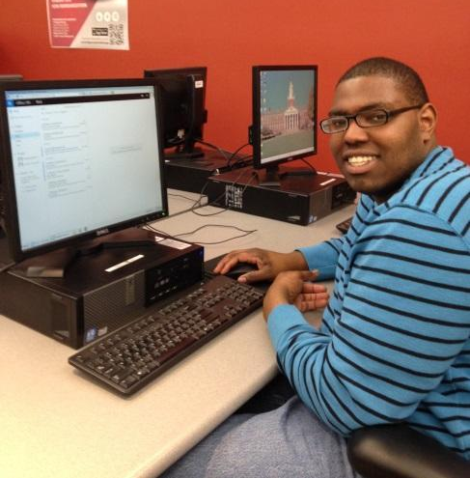
George Lindesey-Travis is a 21-year-old Inclusive Concurrent Enrollment student from Brockton currently attending Bridgewater State University. George was born with Fetal Alcohol Syndrome and was bullied throughout his school years; school was “always a struggle”. He even remembers thinking about suicide.
George’s family and friends always had his back and pulled him through; they helped him be a stronger person and to stand up to bullies. “When I found out that I was accepted into the ICE Program at Bridgewater State, I cried. I never thought there would be a place for special needs kids in college!”
So far, George’s favorite course at Bridgewater State University was his Introduction to Communications course. It gave him more confidence in getting up to talk in front of people. The professor taught several different techniques to become a more inspirational speaker; George eventually learned to come out of his “shy zone”.
“My greatest achievement is being involved in the ICE Program. I get to walk away from this experience with new friends and a better education. I am now ready to go out and teach other students like myself that they can also achieve a lot if they work hard.
“Don’t be a victim just because you have a disability; stand tall! Go with your heart and your passions. Pick classes that will benefit you and help you in what you want to do in the future. Get to know and talk to as many people on campus as possible; and make sure you try every dining hall – the food is delicious!”
As for future and career goals, George aspires to get a job as an assistant chef and hopes to eventually open his own restaurant. As of the publication date of this report, George is now gainfully employed at Bridgewater State University in the dining department and recently won a campus-wide chili cook-off contest.

Appendix D: Student Spotlight (Leslie Garcia)

Leslie Garcia, 21, is participating in her first semester as a college student in the Gateway Scholars Program, the Inclusive Concurrent Enrollment Initiative at Roxbury Community College (RCC). Leslie is also a student at Madison Park High School.
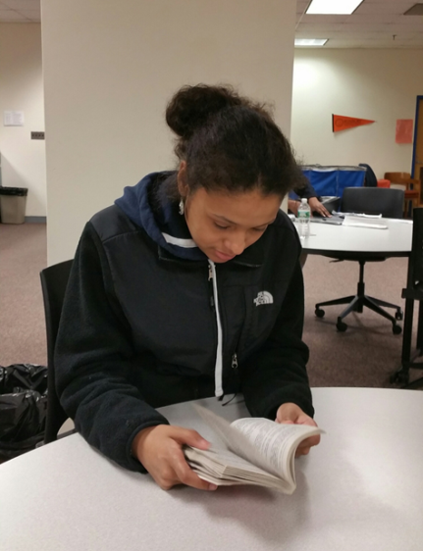
When asked to describe her experiences as a college student, Leslie said, “It feels great coming to RCC! I’ve always wanted to come to RCC to take courses.” Leslie reports that she was motivated to enroll in the Gateway Scholars Program after hearing about it from friends who took part in the program and attending an Open House at Roxbury Community College as a prospective college student.
Leslie is currently enrolled in a developmental reading and writing course since she expressed a desire to continue to build her literacy skills. When asked to talk about her class, Leslie stated, “I like my class at RCC because I am learning new things. I get to meet new friends. Right now, I am reading a play, A Raisin in the Sun, and it is very interesting.”
Professor David Updike, Leslie’s instructor, reports that Leslie “… has been a pleasure to have in class [and] has been a full participant in all classroom activities… I expect her to attend college and I am quite sure she can excel.”
Leslie has utilized campus resources such as the library and the Student Writing Center. Leslie also joined Pizza and Politics, an on campus club that provides opportunities for students to discuss and debate current events. In addition, Leslie participated in campus activities such as a student ‘Open Mic’ event and viewed the ‘Portraits of Purpose’ exhibit at the art gallery.
When asked what she might tell prospective college students who express interest in the Inclusive Concurrent Enrollment Initiative, Leslie said, “I would definitely recommend this program to other students and I would tell people not to be nervous.”

The first two residential life planning grants were awarded in the last and current academic years. Program plans anticipate awarding the first implementation grant(s) for the 2016-17 academic year.
The Department of Elementary and Secondary Education posts data related to student characteristics at http://profiles.doe.mass.edu/profiles/student.aspx.

