MEMORANDUM
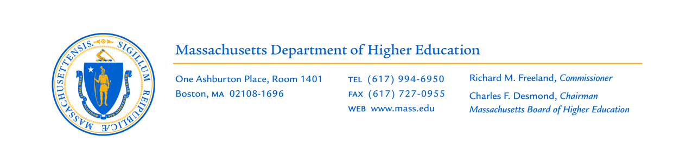

TO: Board of Higher Education
FROM: Richard M. Freeland, Commissioner

DATE: June 30, 2014

SUBJECT: FY15 Conference Committee Budget

On Sunday evening, the Conference Committee released their budget for the upcoming 2015 fiscal year. In general, the outcomes of the reconciliation process between the House and Senate budgets reflect the higher funding scenario of the two legislative bodies, most of which originated in the House.

Overall, the FY15 conference budget provides $32.5 million above FY14, an increase of 5.4% for the ongoing operations, programs, and initiatives of the Department of Higher Education, the Community Colleges, and the State Universities. While not in scale with the funding increase realized for FY14, the conference budget is still a considerable investment for public higher education. In fact, the cumulative increase of approximately 10% since FY13 reflects a two-year funding arc that has not been achieved in recent memory.

Below is a summary of the areas that impact public higher education:

DHE Main Administrative Accounts
- Funding was reduced for the Performance Incentive Fund (PIF) by $4.25 million, down to $3.25 million for FY15. This reduction will prohibit the DHE from initiating a new round of PIF grants but will still enable the Department to fund continuation grants, the common course numbering initiative, and ongoing collaboration and efficiency initiatives across both segments.
- Level-funding for the State University Internship Incentive program at $1 million.
- Supports an initiative in Civic Learning with a $250,000 system-wide grant program aligned with the objectives of the Vision Project.

Financial Aid
- Increases the Massachusetts State Scholarship program by $3 million over FY14, to a total appropriation of $93.6 million
- Level-funding for the Commonwealth Dual Enrollment Program at $750,000
- Level-funding for the Foster Care Financial Aid, Foster Care and Adopted Fee Waiver, and the High Demand Scholarship/Rapid Response Grant Program.
- Supports a new scholarship initiative for Early Educators at $95,000

Workforce Coordination
- Level-funding for the second year of the STEM Academy initiative for the Community Colleges at $4.75 million.
- Level-funding for the administration and allocation of the Community College Workforce Training grants at $1.45 million.
- Level-funding for the STEM Pipeline fund at $1.5 million.
- Decreases funding for the Nursing and Allied Health Initiative from $250,000 in FY14 to $200,000 in FY15.

Community Colleges
- The conference budget supports $13.2 million to be allocated through the community college funding formula as developed by the DHE.
- Funds the known collective bargaining costs in the campus line-items and also provides $1.45 million in a reserve for future collective bargaining expenditures (costs to be determined pending ratification).
- Supports a new $1.95 million initiative for the FAA-certified Airframe and Power Plant Program for Cape Cod Community College.

State Universities
- The conference budget supports approximately $8.1 million to be allocated to the state universities, an aggregate increase of 3.5% over FY14.
- An additional $100,000 is allocated for the development of a state university funding formula.
- Funds $5.5 million in a reserve for future collective bargaining expenditures (costs to be determined pending ratification).
- Supports a new initiative for the MetroWest Planning Center for Framingham State University and MassBay Community College. The $400,000 funding in the conference budget augments seed funding provided in FY14 from a PIF Consortium grant.

Both chambers of the legislature will vote on the conference report in the coming days and, once approved, will be sent to the Governor’s office. The Governor has a 10 day review period to both submit his vetoes and sign the budget into law (the budget is also known as the “General Appropriations Act” or the “GAA”). All vetoes can be overridden in the legislature with a two-thirds majority vote at any point during the current or upcoming legislative session.

We will continue to keep you updated if there are future developments that impact funding for public higher education.

Please feel free to contact me directly if you have any questions.

